Week 9: 20-24 July 2026
1. Research Competitor (XWOD) [1]
1.1. Paper overview
XWOD: A Real-World Benchmark for Object Detection under Extreme Weather Conditions was released as an arXiv preprint in May 2026. It introduces a real-image traffic-object detection dataset and evaluates YOLOv8, YOLO11, and YOLO26 at the nano, small, medium, large, and extra-large scales. [2]

This could be useful for our project:
- It provides a directly relevant unpruned YOLO26n adverse-weather baseline.
- It demonstrates that model performance can vary greatly between weather conditions, supporting the decision to use weather-aware sensitivity instead of relying only on general-dataset accuracy.

1.2 Dataset usage
1.2.1 Dataset summary
Item | XWOD configuration
Total images | 10,010
Total bounding boxes | 42,924
Average boxes per image | 4.29
Weather conditions | 7
Object classes | 6
Image type | Real-world RGB images
Detection type | 2D object detection
Annotation | Axis-aligned bounding boxes
Geographic coverage | Asia, North America, Europe and the United States
Train split | 6,206 images, 62%
Validation split | 1,744 images, 15%
Test split | 2,060 images, 23%
Training epochs | 100
Input resolution | 640 × 640
Model families | YOLOv8, YOLO11, YOLO26
Model scales | n, s, m, l, x
Table 1.1: Dataset summary

Note: The percentages reported in the XWOD paper are inconsistent with the published image counts.

In Table 1.1, XWOD experiment uses 640 × 640 input resolution and 100-epoch training length as YOLO26n configuration. Therefore, its general experimental scale is reasonably relevant, although the datasets and class distributions are different.

1.2.2 Data collection and annotation
XWOD uses real images from public traffic and weather-event photography archives together with dash-camera video frames provided by driving research partners. Objects are annotated when they remain confidently recognizable despite weather degradation; heavily obscured are excluded to reduce annotation noise.
- Real images only
- Augmentation may still be applied during model training

1.3 Weather distribution
1.3.1 Images and object instances by weather
Weather | Images | Dataset share | Instances | Boxes/image | Mean relative box area
Heavy rain | 665 | 6.64% | 3,270 | 4.92 | 0.0244
Snow | 1,203 | 12.02% | 5,599 | 4.65 | 0.0213
Fog | 306 | 3.06% | 1,634 | 5.34 | 0.0333
Haze/Sand/Dust | 560 | 5.59% | 3,321 | 5.93 | 0.0263
Flooding | 5,151 | 51.46% | 21,734 | 4.22 | 0.0368
Tornado | 1,164 | 11.63% | 4,962 | 4.26 | 0.0187
Wildfire | 961 | 9.60% | 2,404 | 2.50 | 0.0586
Total | 10,010 | 100% | 42,924 | 4.29 | 0.0316
Table 1.2: Images and object instances

Table 1.2 shows that snow is the second-largest individual weather subset after flooding. However, the full dataset is strongly imbalanced because flooding represents approximately 51.5% of all images. The paper therefore emphasizes reporting separate results for each weather.

This could support: an overall validation score could hide a serious snow-specific accuracy loss after pruning.

1.3.2 Object-class distribution by weather
Weather | Car | Person | Truck | Motorcycle | Bus | Bicycle
Rain | 73.15% | 9.17% | 13.18% | 1.80% | 2.20% | 0.49%
Snow | 85.25% | 6.14% | 7.02% | 0.02% | 1.55% | 0.02%
Fog | 68.42% | 15.06% | 8.87% | 0.55% | 6.85% | 0.24%
Haze/Sand/Dust | 70.55% | 13.94% | 9.09% | 2.44% | 3.43% | 0.54%
Flooding | 37.56% | 32.37% | 15.17% | 7.23% | 0.77% | 6.89%
Tornado | 64.59% | 27.15% | 7.09% | 0.44% | 0.69% | 0.04%
Wildfire | 48.13% | 37.31% | 12.65% | 0.00% | 1.91% | 0.00%
All conditions | 53.94% | 24.77% | 12.17% | 4.06% | 1.47% | 3.59%
Table 1.3: Object-class distribution

Table 1.3 shows snow subset is extremely car-dominated. Of its 5,599 annotations, approximately 4,773 are cars, while motorcycles and bicycles each account for approximately one annotated instance based on the reported percentages.

XWOD is useful for testing snow traffic, but it is not a balanced benchmark for every traffic class. A high snow mAP may mainly reflect car-detection performance.

For our project, we can report both:
- overall mAP50–95
- per-class mAP (pedestrian, truck, bus, car, etc.)
This will prevent the dominant car class from hiding weaker performance on other objects.

1.4. Evaluation protocols
XWOD defines two main object-detection protocols.

1.4.1 XWOD-Det: Standard detection
The model is trained using the fixed training split and tested on the fixed XWOD test set. The reported metrics are:
- mAP50
- mAP50–95
- precision
- recall
- per-weather mAP

1.4.2 XWOD-Gen: leave-one-weather-out generalization
For each experiment, one weather condition is excluded from training:
$$\text{Train on six weather conditions}→\text{Test on the unseen seventh condition}$$
For example:
$$\text{Train without snow}→\text{Test on snow}$$
The protocol reports the mean and worst per-weather mAP across seven experiments.

A similar optional experiment could test whether our pruned model preserves generalization:
- train or fine-tune without a condition
- test on that
- compare the original and pruned YOLO26n models
That experiment would measure whether pruning removes features required for unseen condition generalization.

1.5. YOLO26 results on XWOD
The following results are evaluated on the complete XWOD test set, containing all seven weather conditions.
YOLO26 model | mAP50 | mAP50–95 | Precision | Recall
YOLO26n | 46.29% | 26.73% | 57.92% | 45.27%
YOLO26s | 51.92% | 30.49% | 63.74% | 50.18%
YOLO26m | 53.34% | 32.29% | 70.40% | 48.24%
YOLO26l | 53.95% | 32.75% | 66.24% | 51.77%
YOLO26x | 53.61% | 32.55% | 67.59% | 51.85%
Table 1.4: YOLO26 results

Table 1.4 shows YOLO26n’s results.

1.5.1 Most relevant baseline
For our project, the most relevant XWOD result is:
$$\text{YOLO26n: }mAP_{50}=46.29\%,mAP_{50-95}=26.73\%$$
with:
$$Precision=57.92\%,Recall=45.27\%$$
This is an unpruned YOLO26n result trained and tested on XWOD.

1.5.2 Effect of increasing model size
Compared with YOLO26n, YOLO26l improves:
- mAP50 by 7.66 percentage
- mAP50–95 by 6.02 percentage
- recall by 6.50 percentage

However, the paper observes that increasing model size does not consistently produce large gains. YOLO26l slightly outperforms YOLO26x, and medium-to-large variants are usually separated by only around 1–2 mAP50 points. The authors conclude that weather-data diversity is at least as important as simply increasing model scale.

This observation could be useful for our resource-limited deployment argument:
Increasing model size is not necessarily the most efficient approach for improving extreme-weather detection. A carefully selected compact architecture may provide a better accuracy–resource trade-off.

1.6 Performance under different weather conditions
The paper’s detailed per-weather table is reported for YOLO11m, not YOLO26n.
Therefore:
- Snow mAP50 = 38.46% is a YOLO11m result
- XWOD does not provide a complete YOLO26n per-weather table in the current version of paper

Weather | mAP50 | mAP50–95 | Precision | Recall
Rain | 60.49% | 37.70% | 61.74% | 61.87%
Snow | 38.46% | 25.93% | 69.79% | 32.19%
Fog | 23.45% | 11.97% | 66.08% | 21.92%
Haze/Sand/Dust | 29.86% | 9.95% | 38.83% | 35.10%
Flooding | 42.86% | 26.36% | 53.15% | 43.73%
Tornado | 68.97% | 43.47% | 75.38% | 57.70%
Wildfire | 17.85% | 12.18% | 60.57% | 15.42%
Table 1.5: per-weather YOLO11m

Table 1.5 reported per-weather YOLO11m results.

According to mAP50:
- Tornado — 68.97%
- Rain — 60.49%
- Flooding — 42.86%
- Snow — 38.46%
- Haze/Sand/Dust — 29.86%
- Fog — 23.45%
- Wildfire — 17.85%

Snow is therefore a moderately difficult condition in XWOD: it is harder than tornado, rain, and flooding, but easier than haze, fog and wildfire for the reported YOLO11m model.

1.7. Interpretation of the snow result
The complete YOLO11m test-set result is:
Scope | mAP50 | mAP50–95 | Precision | Recall
All XWOD weather | 53.84% | 31.93% | 63.33% | 53.47%
Snow only | 38.46% | 25.93% | 69.79% | 32.19%
Difference (%) | −15.38 | −6.00 | +6.46 | −21.28
Table 1.6: All vs snow

In table 1.6, the overall YOLO11m result comes from the family-comparison table, while the snow result comes from the per-weather table.
Snow reduces YOLO11m mAP50 by 15.38 percentage points relative to its full-dataset result. More importantly, recall decreases from 53.47% to 32.19%.
At the same time, snow precision increases to 69.79%.

This combination indicates:
- when it predicts an object, it is often correct
- however, it fails to detect many objects in snow
The main snow problem is not excessive false detection. The larger problem is missing traffic objects.

1.8 XWOD summary
The current paper does not report the following items:
- YOLO26n per-weather mAP
- YOLO26n per-class snow AP
- Parameter count in experiment tables
- Model file size
- FLOPs
- Layer-wise sensitivity
- Structured or layer pruning
- Post-pruning fine-tuning
- Latency or FPS
- PYNQ or FPGA deployment
- Power or resource utilization

Item | XWOD
Base model | YOLO26n and other YOLO scales
Traffic detection | Yes
Snow included | Yes
Snow images | 1,203
Weather types | Seven
Overall YOLO26n mAP50–95 | 26.73%
Per-weather evaluation | Yes, for YOLO11m
Layer sensitivity analysis | No
Weather-aware pruning | No
Physical model reduction | No
Parameter reduction | Not reported
Edge-device latency | Not reported
Hardware resources | Not reported
Main purpose | Weather benchmark
Table 1.7: XWOD information

Table 1.7 shows information about XWOD.

Overall, it contains 10,010 real extreme weather traffic images, including 1203 snow images, and tests different model sizes of YOLOv8, YOLO11, and YOLO26, including YOLO26n. The overall results for YOLO26n in XWOD are 46.29% mAP50 and 26.73% mAP50–95, but no model pruning was performed.

https://arxiv.org/html/2605.11521v1

2 Comparative Evaluation
2.1 Models to Compare
This part, I planned to test on the embedded device.
Model | Purpose
Original YOLO26n | For baseline metrics
Random Prunings | Random competitor
Parameter-Based Pruning | Prove cannot only focus on parameters
GEN-Only Sensitivity Pruning | Prove traditional general-data pruning may have bad results on adverse weather
SNOW-Only Sensitivity Pruning | Prove snow-data pruning may have bad results on general traffic
Proposed GEN+SNOW Pruning | Prove proposed framework have decent performance on both general and adverse weather
(may add more models, to prove our proposed model is relatively good)
Table 2.1: models for comparison

Table 2.1 shows the models that can be used to prove our proposed model is relatively good.

2.2 Metrics for Compare
Detection accuracy
- GEN mAP50–95
- SNOW mAP50–95
- mAP50
- Precision
- Recall
- Per-class AP (car, pedestrian, truck, bus, …)

Model compression
- Number of parameters
- Parameter reduction percentage
- Model file size
- FLOPs
- Number of physically removed layers

Deployment performance
- Latency per image
- Frames per second
- Peak memory usage
- CPU usage
- Power usage

3. Prunability
3.1 Framework Motivation
YOLO26n may still require too much memory and computation for resource-limited embedded platforms such as the PYNQ-Z2. Therefore, pruning can be used to reduce unnecessary parts of the model. [2]

Traditional pruning typically only considers:
- Weight magnitude
- Batch-normalization scaling factor
- Parameter count
- FLOPs
- General validation accuracy

The problem is that a layer that might be unimportant in general traffic imagery could be crucial for extracting important features in snowy conditions, especially under low contrast.

Therefore, pruning only the general dataset might result in a smaller model, but degrades snow and adverse weather detection accuracy.

3.2 Formulation
Each candidate layer is individually pruned and evaluated in two domains:
- GEN: MIO-TCD, a general traffic dataset. [3]
- SNOW: ACDC, a snow-specific traffic dataset. [4]

For each layer i, the normalized GEN accuracy drop is calculated as:
$$AD_{GEN,i}=mAP_{GEN,baseline}-mAP_{GEN,pruned,i}$$
$$NAD_{GEN,i}=\frac{AD_{GEN,i}}{mAP_{GEN,baseline}}$$
The normalized SNOW accuracy drop is calculated as:
$$AD_{SNOW,i}=mAP_{SNOW,baseline}-mAP_{SNOW,pruned,i}$$
$$NAD_{SNOW,i}=\frac{AD_{SNOW,i}}{mAP_{SNOW,baseline}}$$
The sensitivity of layer i is defined as:
$$S_{i}=NAD_{GEN,i}-NAD_{SNOW,i}$$

The parameter percentage of layer i is calculated as:
$${Parameters\%}_{i}=\frac{{Parameters}_{i}}{Total Model Parameters}×100$$

The Prunability score of layers i is defined as:
$$P_{i}=\frac{{Parameters\%}_{i}}{S_{i}}$$

3.2.1 example
Given:
$$mAP_{GEN,baseline}=0.50$$
$$mAP_{GEN,pruned,i}=0.48$$
$$mAP_{SNOW,baseline}=0.30$$
$$mAP_{SNOW,pruned,i}=0.294$$

Layer i contains 20,000 parameters
The model contains 2,000,000 parameters

Calculations:
$$AD_{1,i}=0.50-0.48=0.02$$
$$NAD_{1,i}=\frac{0.02}{0.50}=0.04$$

$$AD_{2,i}=0.30-0.294=0.006$$
$$NAD_{2,i}=\frac{0.006}{0.30}=0.02$$

$$S_{i}=0.04-0.02=0.02$$

$${Parameters}_{\%,i}=\frac{20,000}{2,000,000}×100=1$$

$$P_{i}=\frac{1}{0.02}=50$$

3.3 Setup
(pending)

3.4 Results
(pending)

3.5 YOLO26n Pruning for Resource-Limited Devices
The main idea is to progressively prune YOLO26n until it satisfies the resource limits of the selected embedded platform. The final model should meet requirements for memory usage, model size, latency, FPS, etc. while keeping the accuracy loss within an acceptable range. (to determine the number of layers)

Previous studies support this approach. NetAdapt adjusts a neural network according to the measured performance of the target device. [5]

DepGraph shows that connected layers and channels should be pruned together to avoid input and output dimension mismatches [6]. For YOLO26n, low-sensitivity layers or blocks can be removed completely (if we have a good way to do so), while structured channel pruning can be used when removing a whole layer would damage the network structure.

4. Embedded Platform (PYNQ-Z2)
The PYNQ-Z2 board was selected as the embedded platform for testing the deployment of the YOLO26n models. It combines an ARM processor with FPGA programmable logic. [7]

4.1 Initial Setup / Test
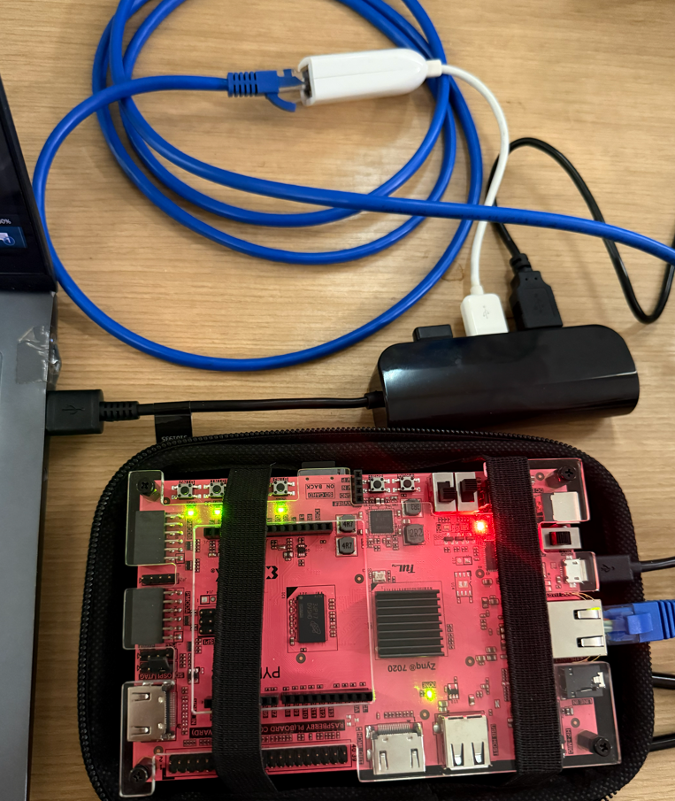
Figure 4.1: laptop-PYNQZ2 connection

Figure 4.1 shows the wire connections.

Here are the steps for me to use the PYNQ-Z2 on the pc:
- Connect them with wires
- Search for the COM port from device manager, in my case, it is COM4.
- In Mobaxterm, select section, serial, and insert COM4, with 115200 speed, 8 data bits, 1 stop bit, none parity, none flow control.
- Test python with [python3 -c "print('hello')"]
- Check the IP by [hostname -I], it is 192.168.2.99 for this board

- Go to the advanced network settings, find the Ethernet, and edit the properties: 192.168.2.1 (or 192.168.2.[1-254], just not 99 because 99 is the board) for IP, 255.255.255.0 for subnet mask
- Try [ping 192.168.2.99] (the board) in PowerShell, the same IP should reply

- In Mobaxterm select section, ssh, and use xilinx as username, with port 22
- After entering, the password is also xilinx
- Done, it can be used in a local pc

4.2 Hardware Details
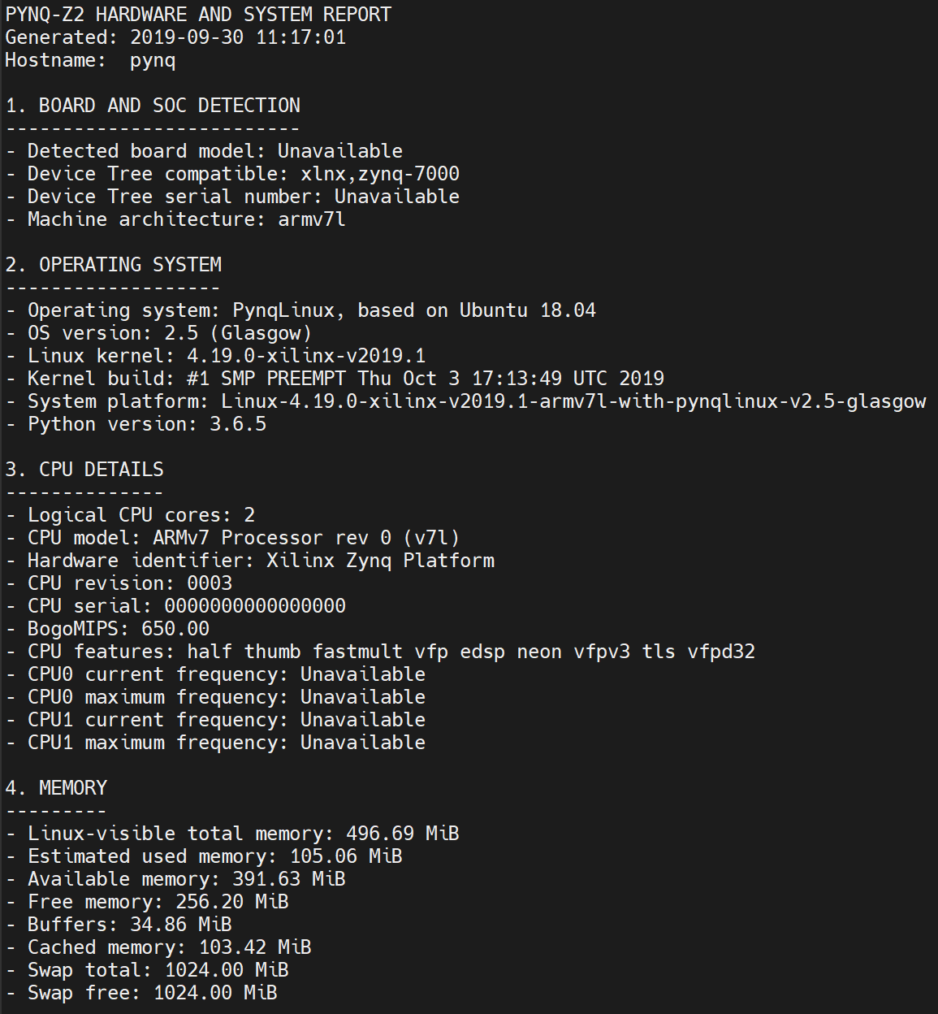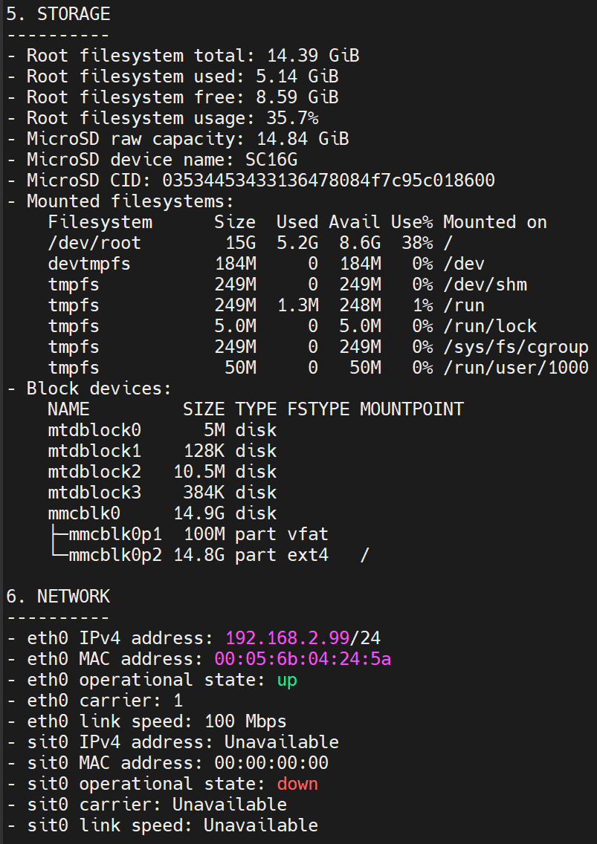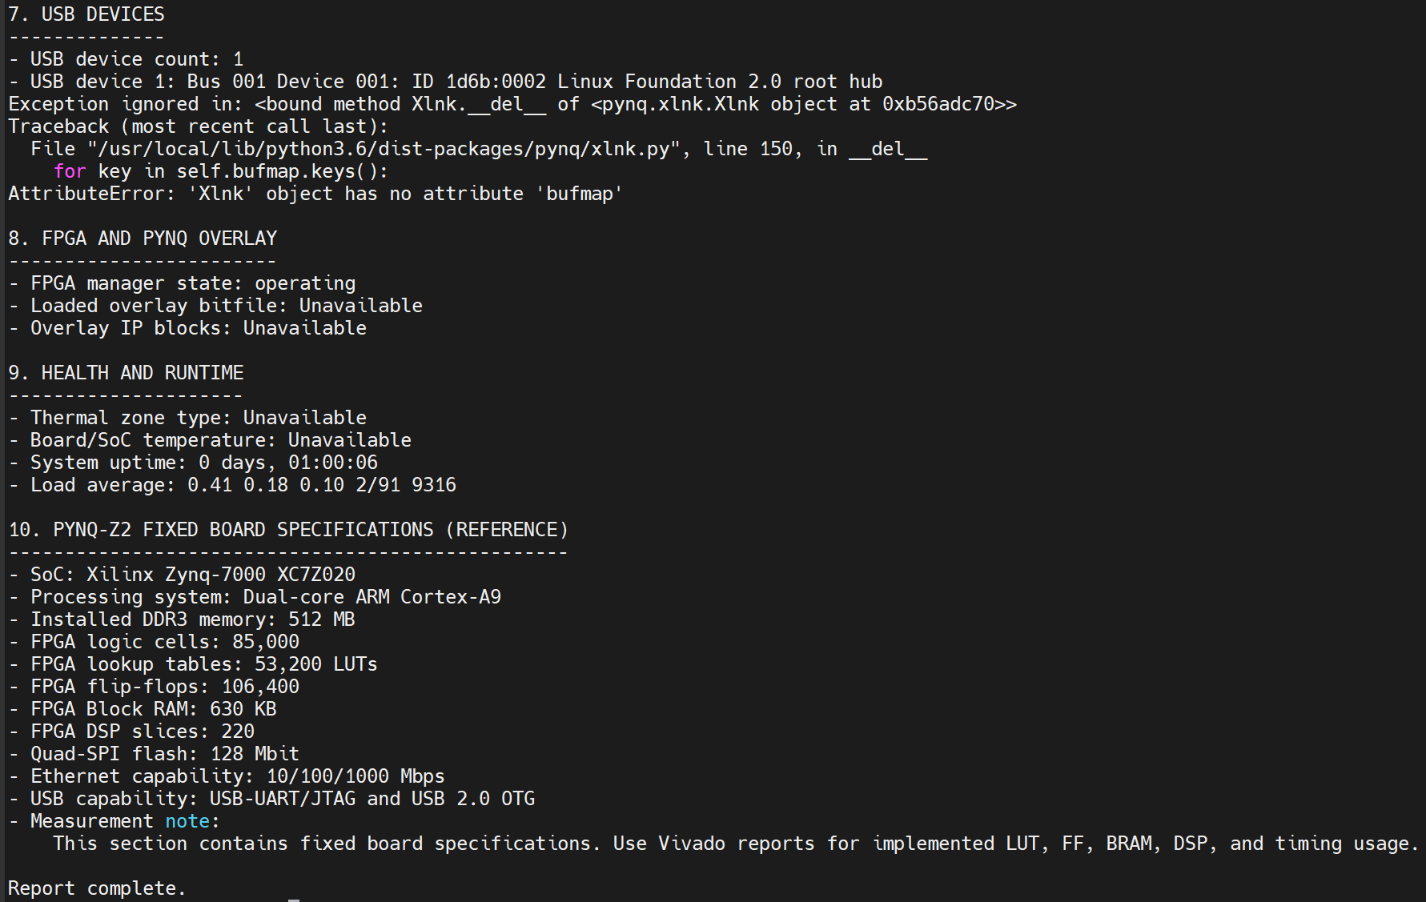
Figure 4.2: PYNQ-Z2 details

For Figure 4.2, it can be summarized into a shorter version:

Hardware / Software Item | Observed Detail
Embedded platform | PYNQ-Z2
System-on-Chip | Xilinx Zynq-7000 XC7Z020
Processing system | Dual-core ARM Cortex-A9
CPU architecture | ARMv7 (armv7l)
CPU cores | 2
Installed memory | 512 MB DDR3
Linux-visible memory | 496.69 MiB
Operating system | PynqLinux 2.5, based on Ubuntu 18.04
Linux kernel | 4.19.0-xilinx-v2019.1
Python version | 3.6.5
Main storage | 14.84 GiB MicroSD card
Available root storage | Approximately 8.59 GiB
Network interface | Ethernet
Current Ethernet speed | 100 Mbps
SSH IP address | 192.168.2.99/24
FPGA Manager status | Operating
FPGA resources | 53,200 LUTs,  106,400 flip-flops,  220 DSP slices,  630 KB Block RAM
Table 4.1: PYNQ-Z2 details [8]

Table 4.1 shows the PYNQ-Z2’s hardware details.

4.3 Baseline Model Test
(pending)

5. Summary
Research
XWOD provides a relevant adverse-weather benchmark containing 10,010 real-world images, 42,924 annotated objects, seven weather conditions, and an unpruned YOLO26n baseline.

YOLO26n achieves 46.29% mAP50 and 26.73% mAP50–95 on the complete XWOD test set, demonstrating the difficulty of extreme-weather traffic detection.

The reported YOLO11m results show that the snow subset has 38.46% mAP50 and 32.19% recall, indicating that missed detections are a major challenge under snowy conditions.

Because XWOD has imbalanced weather and class distributions, the evaluation included overall, per-weather, and per-class results rather than relying only on one aggregate mAP value. [1]

Metrics
The comparative evaluation would include the original YOLO26n, random pruning, parameter-based pruning, GEN-only pruning, SNOW-only pruning, and the proposed GEN+SNOW pruning method.

Pruning
The proposed framework evaluates each pruning candidate on the MIO-TCD general-traffic dataset and the snow subset of ACDC to identify components that can be removed without seriously degrading either general or snow-condition accuracy [3], [4].

The model could be progressively compressed according to measured embedded-platform constraints, while dependency-aware structured pruning can be used to maintain valid channel connections between coupled layers [5], [6].

Embedded Platform
The PYNQ-Z2 setup has been successfully tested.

Next Steps
The next steps are to complete the pruning experiments, deploy the original and pruned models on the PYNQ-Z2, and compare their accuracy, model size, latency, FPS, memory usage, and resource usage.

References

[1] Chen et al., XWOD: A Real-World Benchmark for Object Detection under Extreme Weather Conditions, 2026. https://arxiv.org/abs/2605.11521

[2] Jocher et al., Ultralytics YOLO26: Unified Real-Time End-to-End Vision Models, 2026. https://arxiv.org/abs/2606.03748

[3] Luo et al., MIO-TCD: A New Benchmark Dataset for Vehicle Classification and Localization, 2018. https://doi.org/10.1109/TIP.2018.2848705

[4] Sakaridis et al., ACDC: The Adverse Conditions Dataset with Correspondences for Semantic Driving Scene Perception, 2021. https://openaccess.thecvf.com/content/ICCV2021/html/Sakaridis_ACDC_The_Adverse_Conditions_Dataset_With_Correspondences_for_Semantic_Driving_ICCV_2021_paper.html

[5] Yang et al., NetAdapt: Platform-Aware Neural Network Adaptation for Mobile Applications, 2018. https://openaccess.thecvf.com/content_ECCV_2018/html/Tien-Ju_Yang_NetAdapt_Platform-Aware_Neural_ECCV_2018_paper.html

[6] Fang et al., DepGraph: Towards Any Structural Pruning, 2023. https://openaccess.thecvf.com/content/CVPR2023/html/Fang_DepGraph_Towards_Any_Structural_Pruning_CVPR_2023_paper.html

[7] TUL Corporation, PYNQ-Z2 Product Specification and User Manual, accessed 22 July 2026. https://www.tulembedded.com/FPGA/ProductsPYNQ-Z2.html

[8] Xilinx, Zynq-7000 SoC Family Product Selection Guide, 2019. https://docs.amd.com/api/khub/documents/1L_hkh2pbc5l0Oz7tcLspA/content

